Mostafa

Kamal

**CAREER OBJECTIVE**

# CONTACT

01836-238689, 01880-945289

[mostafakamal8689m@gmail.com](mailto:mostafakamal8689m@gmail.com)

Shamsu Bhavan, Sholokbahor Chandgaon,Panclaish,Chattogram.

# IT SKILLS

Ms Office Powerpoint Email

# LANGUAGE SKILLS

Bengali English

# PERSONAL SKILLS

*Hard Work

*Leadership

*Team work

*Time management

# PERSONAL INFO

Name : Mostafa Kamal Father’s Name : Kamal Uddin

Mother’s Name : Miraju Begum Permanent Address : Vill: Shatghor Para, P.O: Matar Bari P.S: Moheskhali, Dist: Cox’s Bazar. Date of

Birth : 25th June, 1997

To contribute in an organization where I can utilize my knowledge, Skills and abilities to add value to that organization and explore my potentials. I strongly believe that excellent performance and commitment need proper guidance and leadership.

**EDUCATION**

## Masters of business administration (EMBA) - (2020-2021 )

*University of Chittagong (Finance & Banking) Gpa 3.40 out of 4.00*

**Bachelor of Business Administration (BBA) - (2016-2019 )** *International Islamic University Chittagong(Finance & Banking) Gpa 3.61 out of 4.00*

**Higher Secondary Certificate (HSC) - (2013-2014 )** *Chittagong Govt. City College (Bussiness Studies) Gpa 3.50 out of 5.00 (board-chattogram)*

**Sesondary School Certificate (SSC) - (2011-2012 )** *Matar Bari High School (business studies) Gpa 5.00 out of 5.00 (board-chattogram)*

# WORK EXPERIENCE

1. Internship at Mutual Trust Bank, Rahattarpul Branch,Chittagong on "General Banking Activities". (20 November 2019 to 20 January 2020)
2. National Household Database (NHD) in 2018.

**REFERENCES**

Religion : Islam

Marital Status : Unmarried. Gender : Male

Nationality : Bangladeshi. National ID No : 5103327994

## Nur Uddin

36th BCS (General Education) Designation:Lecturer(Economics) Address:Department of Economics Cos'x Bazar Govt. College.

Phone: +8801718134784

Email: [nursbd71@gmail.com](mailto:nursbd71@gmail.com) Declaration

## Mohammad Enamul Hoque

AVP & Manager Global Islami Bank Ltd.Cox's Bazar Branch

Phone: +8801711572087

Email:mohmmed.enamul@globalislamibankbd

I hereby declare that the information given above is true and correct to the best of my

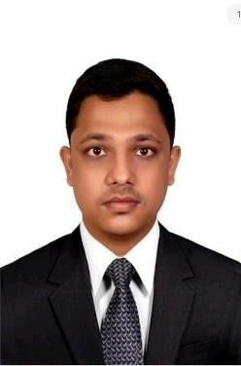

knowledge and belief.

…………………………